TRADE OF
Pipefitting

PHASE 2

Module 2

Thermal Processes

UNIT: 4

Metal Active Gas Shielded Welding (MAGS/MIG)

Produced by

In cooperation with subject matter expert:

Finbar Smith

© SOLAS 2014
Table of Contents
Unit Objective 1
Learning Outcome 2
1.0 Metal Arc Gas-Shielded (MAGS) Welding 3
1.1 Metal Inert Gas (MIG) or Gas Shielded Metal Arc Welding 3
1.2 Description of the Process 4
1.3 Metal Transfer in MAGS Welding 5
1.4 Applications for MAGS 6
2.0 Equipment Used for MAGS Welding 7
2.1 MAGS Power Sources 7
2.2 Types of Torches Used for MAGS Welding 8
2.3 Wire Feed Unit 8
2.4 Setting Up a MAGS Welding Plant 8
2.5 Electrode Wire Size 10
2.6 Self-Shielded Flux Cored Wire 10
2.7 Wire Extension 11
2.8 Contact Tips and Nozzles 11
2.9 Welding Speed 11
2.10 Gases used for Gas Shielded Metal Arc Welding Process 12
2.11 Programmable Welding Plants 13
3.0 Hazards and Safety Procedures When MAGS Welding 14
3.1 Safety Precautions 14
4.0 Welding Techniques 16
4.1 Gas Flow Rates 16
4.2 Torch Angle 16
4.3 Tack Welds 17
4.4 Welding Positions 18
4.5 MAGS Welding in the Flat Position 18
4.6 MAGS Welding in the Horizontal and Vertical Position 20
4.7 Pipe and Tube Welds 22
4.8 MIG Welding of Aluminium 23
5.0 Identify Weld Defects and Their Causes 24
5.1 Weld Quality 24
5.2 MAGS Weld Defects and Their Causes 24
Suggested Exercises 26
Additional Resources 26

Unit Objective
There are seven Units in Module 2. Unit 1 focuses on Introduction to Thermal Process and safety, Unit 2; Introduction to Oxy-acetylene welding, Unit 3; Manual Metal Arc welding, Unit 4; Metal Active Gas welding, Unit 5; Tungsten Active Gas welding, Unit 6; Oxy-fuel cutting and Unit 7 Plasma arc cutting.
In this unit you will be introduced to Metal Active Gas Shielded welding (MAGS) and the safety precautions required when using MAGS equipment. Note: MAGS is also commonly referred to as Metal Inert Gas (MIG) welding but for the purpose of this document we will only refer to it as MAGS.
Module 2
Thermal Processes
Unit 1
Introduction to Thermal Processes and Safety

Unit 2
Introduction to Oxy-Acetylene Welding
Unit 3
Manual Metal Arc Welding
Unit 5
Tungsten Active Gas Shielded Welding
Unit 4
Metal Active Gas Welding
Unit 6
Oxy-Fuel Cutting
Unit 7
Plasma Arc Cutting

Learning Outcome
By the end of this unit each apprentice will be able to:
- Describe the Metal Active Gas Shielded (MAGS/MIG) welding process and applications
- Identify MAGS/MIG welding power source, shielding gases and ancillary equipment
- State the safety precautions and PPE required when using MAGS/MIG welding Equipment
- Select suitable filler wire and fit to wire feed unit
- Set up MAGS welding equipment and adjust welding parameters to produce sample weld beads

1.0 Metal Arc Gas-Shielded (MAGS) Welding

Key Learning Points
- Define the MAGS/MIG welding process
- Identify what occurs in the (MAGS) welding process
- Identify the types of metal transfer during MAGS welding
- Identify applications for MAGS welding

1.1 Metal Inert Gas (MIG) or Gas Shielded Metal Arc Welding
The process is known by different names, such as MIG (metallic inert gas), CO² welding (when a carbon dioxide gas shield is employed), metal active gas welding and, in the USA, gas metal-arc welding. In Ireland and the UK, the most widely accepted name is MAGS (metal arc gas-shielded welding) because this term covers shielding gases other than inert gases, and also gas mixtures.
Because the MAGS process is semi-automatic, it is suitable for full automation on certain types of work and is used quite widely in robot form.
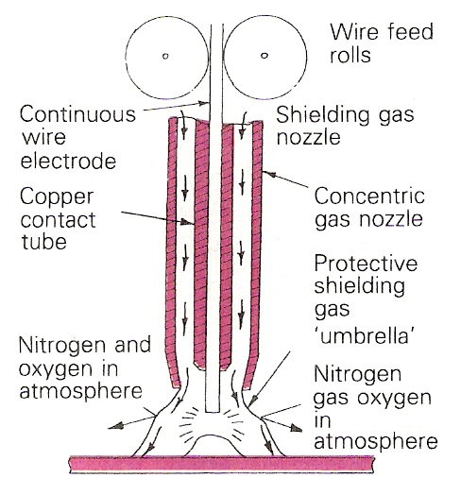
Diagram of Welding Nozzle and Gas Shield for Metal Arc Gas-Shielded (MAGS) Welding

1.2 Description of the Process
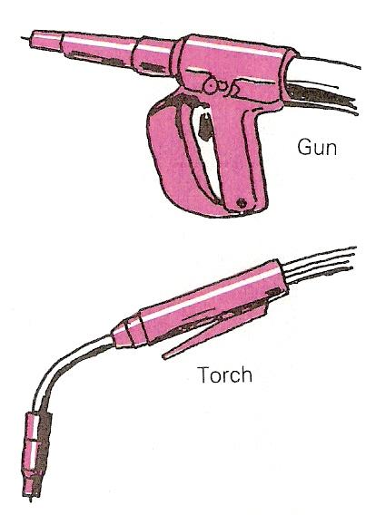
A continuous consumable wire electrode is fed through a welding gun fitted with a concentric gas nozzle. The arc is struck between the workpiece and the wire, which acts as both electrode and filler. The arc and the weld pool are shielded from atmospheric contamination by passing a suitable gas through the nozzle to form a protective shield around the welding area.
MAGS Welding Gun and Welding Torch
Some guns can have an outer nozzle attachment for fume extraction. This has to be carefully set so as not to disturb the gas shield.
For non-ferrous metals, pure argon is usually used as the gas shield. Other gases can be used, such as helium or (for copper) nitrogen. For ferrous metals, the gases used include carbon dioxide, argon and oxygen, argon and CO².
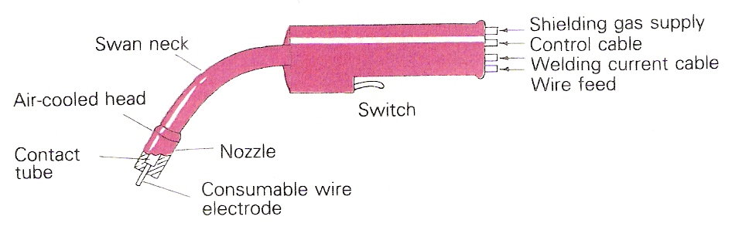
Air-Cooled Welding Torch
The arc is self-adjusting, which means that any variation in the arc length made by the welder produces a change in the burn-off rate of the electrode, and the arc rapidly returns to its original length.

1.3 Metal Transfer in MAGS Welding
There are three main types of metal transfer: spray transfer, pulsed transfer and dip transfer.
In spray transfer, droplets of metal are transferred from the end of the electrode in the form of a fine spray. It is usually used for welding thicker plate in the flat and horizontal/vertical positions.
Spray transfer requires the use of higher welding current and arc voltages. The resulting fluid state of the molten pool prevents it from being used for welding steels in positions other than flat or horizontal/vertical. Aluminium, however, can be welded in all positions using spray transfer.
There are two types of spray transfer. The true spray is obtained when the shielding gas is argon or argon/oxygen mixture. With these gas shields, the droplets in the spray are very fine and never short-circuit the arc. When carbon dioxide or an argon/carbon dioxide mixture is used, a molten ball tends to form at the end of the electrode. This can grow in size until it is bigger than the diameter of the electrode. These large droplets can cause short circuits to occur. This mode is known as globular transfer. With conditions that cause the short circuits to occur very rapidly, the mode becomes short-circuiting or dip transfer.
Spray Transfer
- Droplet forming
- Droplet being ‘pinched’ off
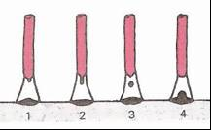
- Droplet in free flight
- Droplet deposited in molten pool
Dip or Short-Circuiting Transfer
- Electrode short-circuits
- Current increases
- Arc re-ignited
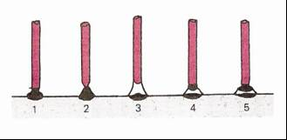
- End of electrode heating up
- Electrode about to short circuit. Cycle repeats.
Pulsed Arc Transfer
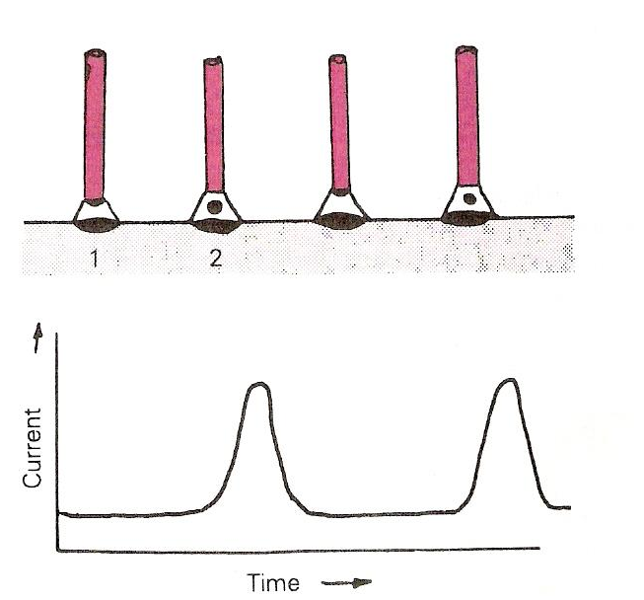
- Background current maintaining arc
- Pulsed current projects metal droplet across the arc gap

1.4 Applications for MAGS
The process is suitable for a great variety of ferrous and non-ferrous metals. The temperatures involved are relatively low and hence the process is suitable for thin sheet sections (less than 6 mm).
MAGS and TIG are competing more or less for similar welding applications. However, TIG welding becomes troublesome when currents increase above 300 A. The MAGS welding process does not suffer from these disadvantages. Thus larger welding currents can be used with bigger deposition rates.
The process is particularly suitable for aluminium, magnesium alloys, plain and low-alloy steels, stainless and heat resistance steels, copper and bronze.
It is versatile process and relatively easy to train operators. It lends itself to automation and it is used in conjunction with robotics.

2.0 Equipment Used for MAGS Welding

Key Learning Points
- Identify equipment used for MAGS welding
- Identify how to set up MAGS welding plant for welding
- Identify different gases used for MAGS welding and their applications.
- Location and use of electricity emergency stop button/s, gas shut off tap and fire extinguishers

2.1 MAGS Power Sources
Transformer-rectifiers are normally used for metal-arc gas shielded welding. A.C. equipment is suitable for welding with gas shielded flux cored electrodes. Motor generator power sources of suitable design may be used in certain circumstances.
Three forms of metal transfer across the arc are in common use. Power sources are available which make it possible to select the appropriate circuit arrangement for each type of transfer.
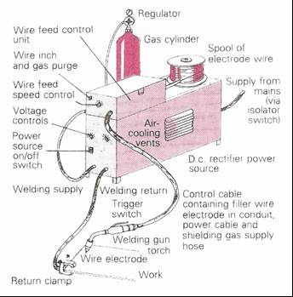
Direct current using either a rectifier or generator is used in the M.A.G.S. welding system with the polarity of the electrode being positive. The power source characteristic is a ˝flat˝ power source for a constant potential machine.
Basic Set-Up for MAGS Welding

2.2 Types of Torches Used for MAGS Welding
There are several types of torch but they may be divided into the gas-cooled and water-cooled types. The drive may be by electric motor with the wire spool on the hand-held gun, by air motor, or simply by a wire-feed push gun. A gas-cooled light-duty swan-neck torch is shown below.
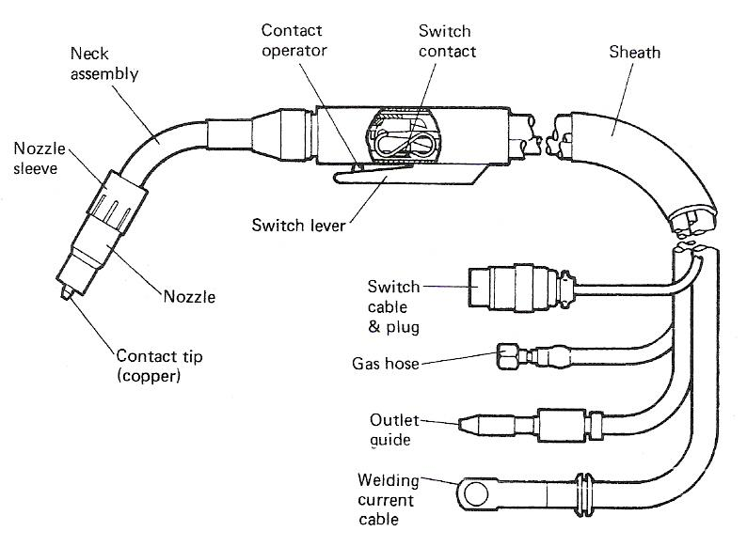
Light-Duty Swan-Neck Torch

2.3 Wire Feed Unit
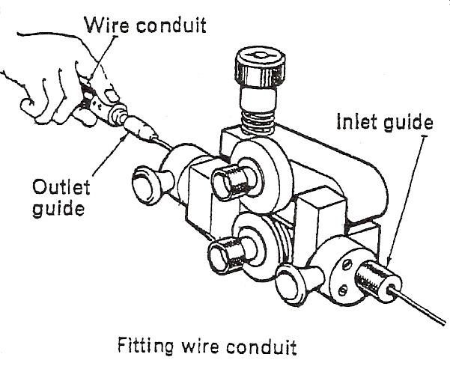
The wire feed unit takes the consumable electrode from a roll and feeds it to the torch.
Wire Feed Unit.
SAFETY: Do not touch electrode wire when the current is switched on.

2.4 Setting Up a MAGS Welding Plant
Controls
All equipment will have the following controls:
- Voltage control - governs arc length.
- Wire feed control - governs welding current.
Equipment designed specifically for Dip Transfer welding will have an additional control:
- Inductance control. This governs the rate of rise of current during short circuit and therefore it controls the frequency of short-circuiting and the weld profile. It is also used to regulate the amount of spatter.
Equipment designed for Pulse Transfer will have additional controls:
- Pulse height control. This regulates the maximum voltage of each pulse.
- Pulse frequency control. This may be fitted on some power sources.
General Instructions
The following general instructions, which are not repeated in the text, apply to metal-arc gas shielded welding. Always:
- Comply with the prescribed safety precautions and fire prevention procedure.
- Check that the return lead is firmly connected to bench and power source.
- Check that all connections to wire feed and/or control unit are in good order.
- Check that gas and water hoses are not ‘kinked’ or otherwise obstructed.
- Check that power source is switched on.
- Check that the gas cylinder valve is open and when using carbon dioxide from syphon cylinder that the heater-vaporiser is switched on.
- Check that the regulator pressure is set to 30 lb./in.².
- Check that correct size contact tube/tip is fitted to gun/torch.
- Check that correct size gas nozzle is fitted.
- Check that the electrode wire extension and the relative positions of the exit ends of the contact tube and gas nozzle are correct.
- Check that the ‘burn-off’ control (if fitted) is adjusted so that the electrode wire extension is correct after breaking the arc.
- Check that the gas flow is correctly set (while purging the air from the flexible tube assembly).
- Check that the water supply is turned on if using a water-cooled gun.
In addition to the general instructions given above others apply depending upon the type of equipment and the welding technique to be employed.
Operating Spray Transfer Equipment
- When fitted, the inductance control should be set at minimum.
Set open circuit voltage about 5 - 6 V above the recommended operating voltage.
- Select the correct diameter and type of wire and set the wire feed speed control to the recommended value.
- When welding commences adjust the wire feed speed control to give correct current, i.e. correct heat input.
- Adjust voltage to correct value as indicated the correct weld profile:
- Narrow weld, high excess metal - raise voltage.
- Wide, flat weld - lower voltage.
Warning: on some power sources the current must be switched off before adjusting voltage.

2.5 Electrode Wire Size
Generally speaking, the smaller-diameter wires will give greater current density, resulting in a fast burn-off rate and a tendency to give deeper-penetration welds.
Modern MAGS welding machines have an automatic inductance, but older machines may need a manual setting. The inductance is used for dip transfer welding. Increasing the inductance for a given open-circuit voltage produces a hotter arc, which results in quieter welding conditions with less spatter and a smoother weld finish. Decreasing the inductance produces a cooler arc that gives out a distinctive 'crackling' sound and a weld surface with a more pronounced ripple.
On machines that require manual adjustment, high inductance will be needed for thicker materials and low inductance for thin sheet.

2.6 Self-Shielded Flux Cored Wire
Self-shielded flux cored wires are used without an additional gas shield and can be usefully employed in outdoor or other on site draughty situations where a cylinder-supplied gas shield would be difficult to establish.
The core of these wires contains powdered metal together with gas-forming compounds and deoxidisers and cleaners. The gas shield formed protects the molten metal through the arc and slag-forming compounds form a slag over the metal during cooling, protecting it during solidification. To help prevent absorption of nitrogen from the atmosphere by the weld pool, additions of elements are made to the flux and electrode wire to effectively reduce the soluble nitrogen.
This process can be used semi- or fully automatically and is particularly useful for on-site work.

2.7 Wire Extension
The length that the electrode wire extends beyond the contact tip can also affect weld quality. With more wire protruding, the arc current will be reduced and this will result in less penetration. Wire extension from the contact tip should be approximately:
- For dip transfer: 3-6 mm
- For spray transfer: 18-30 mm
- For flux-cored wire: 30-45 mm

2.8 Contact Tips and Nozzles
On some torches and guns, the positions of contact tip and nozzle can be adjusted to allow greater visibility of the welding area or accessibility to the particular joint and/or to improve gas shielding.
Always use the correct size of contact tip. A brief spray with silicon 'anti-spatter' solution before use and at regular intervals during use will make it easier to remove spatter from the nozzle and tip. Clean the nozzle and tip regularly.
Mode of Metal Transfer | Recommended Position of Control Tip
Dip | 3-9 mm beyond the end of the nozzle to allow greater visibility / accessibility
Spray (on steels) | 6-9 mm within the nozzle to give improved gas shielding
Spray (on aluminium) | 9-12 mm within the nozzle to give improved gas shielding
Spray (using flux-cored wire) | 9-18 mm within the nozzle to give improved gas shielding and contact tube protection

2.9 Welding Speed
Perfection with MAGS welding, as with any other welding processe will only come with adequate practice under guidance.
When you are learning MIG welding, you must pay special attention to obtaining the correct welding speed. Too fast a welding speed can cause excessive spatter and undercut. Shielding gas can get trapped in the quickly solidifying weld metal, causing porosity. Too slow a welding speed may cause excessive penetration.

2.10 Gases used for Gas Shielded Metal Arc Welding Process
The title MIG is not completely true, as not all gases used are inert gases. Other gases such as CO₂ and oxygen are also used as shielding gases. The title metal Active Gas (MAG) is used in these cases.
Argon
Although argon is very suitable for non-ferrous metals and alloys, if it is used for welding steel the process becomes unstable and the weld profile uneven. Mixtures of argon and oxygen result in more stable process and gives optimum welding conditions for various metals.
Helium
If helium is used as the shielding gas, it requires significantly greater gas flow than argon. It is usually used mixed with argon e.g. argon – 15% helium for certain high nickel alloys, argon – 50% helium for copper welding.
Carbon Dioxide
Pure CO₂ is the cheapest of the shielding gases and can be used for welding steel up to 0.4% C and low alloy steel. CO₂ is not suitable for stainless steel because the corrosive resistance of the weld is reduced.
Argon + CO₂ (5% and “20%)
The addition of CO2 to argon for the welding of steels improves the ‘wetting’ action, reduces surface tension and makes the molten pool more fluid. The mixture is more expensive than pure CO2 but gives a smoother, less critical arc with reduced spatter and a flatter weld profile.
Argon + Nitrogen (15-20%)
The mixture can be used instead of pure argon for copper welding. Arc voltages are higher, giving greater heat output for a given current value thus reducing the pre-heating requirements. If pure nitrogen is used the droplets are of coarse size and there is more spatter and porosity with poor weld appearance.
CO₂ is used to weld Carbon, carbon-manganese and high strength low alloy steels. The choice depends on the composition of the steel and the operating requirements.
General guidelines:
- Penetration increases with the addition of helium. Penetration also increases with higher carbon dioxide contents.
- Carbon dioxide can be useful for fillet welds in thick plate.
- Spatter increases with increase in carbon dioxide content.
- Steel which contains chromium needs special consideration. There is a danger that carbon dioxide in the gas will react with the chromium to form a carbide. This renders the chromium in the steel less effective. The amount of carbon dioxide which can be tolerated depends on the chromium content.

2.11 Programmable Welding Plants
Sets are now also available with programmable power sources. Using tested parameters such as amperes, seconds, metres per minute feed, the welding program is divided into a chosen number of sections and the welding parameters as indicated previously are used to program the computer which controls the welding source. The program can be stored in the computer memory of up to say 50 numbered welding programs or it can be stored on a separate magnetic data card for external storage or use on another unit. By pressing the correct numbers on the keyboard of the unit any programs can be selected and the chosen program begins, controlling welding current, shielding and backing gas, gas pre-flow, wire feed speed, arc length, pulsed welding current and slope control, etc. All safety controls are fitted and changes in the welding program can be made without affecting other data.

3.0 Hazards and Safety Procedures When MAGS Welding

Key Learning Points
- Identify specific hazards pertinent to MAGS welding
- Identify how these hazards are eliminated or minimised

3.1 Safety Precautions
The safety precautions to be observed with MAGS welding is similar for other metal arc processes with certain modifications.
In confined spaces gas shields, if not allowed to escape, may displace oxygen and cause suffocation. Degreasing agents such as trichloroethylene and carbon tetrachloride decompose around the arc to form poisonous compounds. Local fume extraction should be used when employing very high current densities or flux core electrode wire, and filter breathing pads to prevent inhaling oxide dust. Correct grades of screen glass should be used as ultra violet light is greater when welding aluminum with an argon shield compared with other processes. Adequate protective clothing should always be worn.
- The protective clothing and protective equipment as used for manual metal-arc welding are applicable. The amounts of ultra-violet and infra-red radiation, as well as the visible light radiation, are however more intense and full precautions must be exercised.
- Check that there is good ventilation of the working area to prevent the build-up of harmful concentration of gases. Remember that carbon dioxide is heavier than air.
- Ensure that proper precautions are applied when hot material is left un-attended, especially aluminium.
- Be aware of electrical leads and the fatal consequences of contact bared electrical wires
- Have full control of the torch/gun and hold it steady. Concentrate on watching the welding operation.
- Support the flexible hose assembly so that drag on the torch/gun is reduced.
- Hold the torch/gun with just sufficient grip at the point of balance to give control. Otherwise it will cause muscle fatigue. Position yourself to avoid over-balancing.
- Warn any bystanders when about to strike the arc.
- Ensure that any portable welding screens required are in position.
- Ensure protection from radiation reflected from bright surfaces. Screen or temporarily cover polished surfaces in the vicinity.
- Keep the welding mask in front of the eyes until the arc is broken.
- Follow correct procedures when handling gas cylinders .
- Follow closing down procedure at the end of the work period or when there is a long interruption.
Please refer to your instructor for additional information, which is available from the automotive technical manuals.

4.0 Welding Techniques

Key Learning Points
- Identify relevant parameters for MAGS welding
- Identify different welding positions for welding
- Identify how to set parameters on a MAGS welding plant to complete successful welding.
- Identify why MIG welding is used for aluminium welding.

4.1 Gas Flow Rates
Gas flow rate can greatly affect the quality of the weld. Too low a flow rate gives inadequate gas shielding and leads to the inclusion of oxides and nitrides, while too high a rate can introduce a turbulent flow of the CO² which occurs at a lower rate than with argon. This affects the efficiency of the shield and leads to a porosity in the weld. The aim should be to achieve an even non-turbulent flow and for this reason spatter should not be allowed to accumulate on the nozzle, which should be directed as nearly as possible at 90° to the weld, again to avoid turbulence.

4.2 Torch Angle
The torch angle is, in practice, about 70-80° to the line of travel consistent with good visibility and the nozzle is held about 10-18 mm from the work. If the torch is held too close, excess spatter build-up necessitates frequent cleaning, and in deep U or V preparation the angle can be increased to obtain better access. Weaving is generally kept as low as convenient to preserve the efficiency of the gas shield and reduce the tendency to porosity. Wide weld beads can be made up of narrower 'stringer' runs, and tilted fillets compared with HV fillets give equal leg length more easily, with better profile.
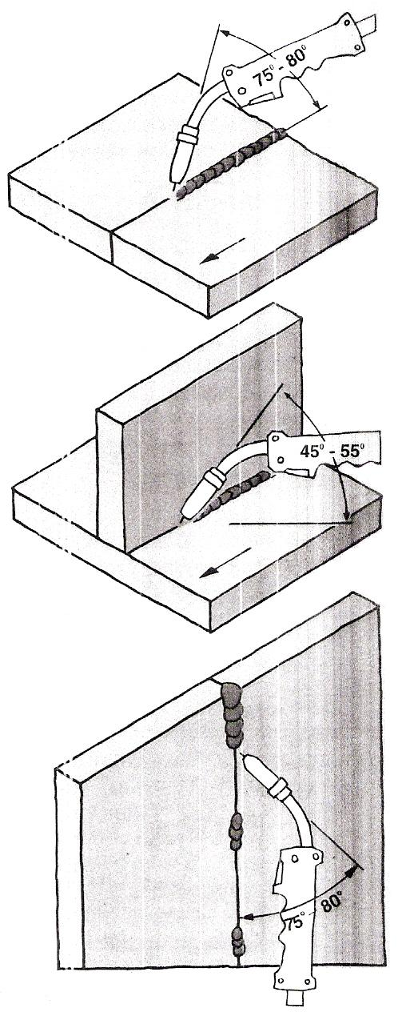
Torch Angles

4.3 Tack Welds
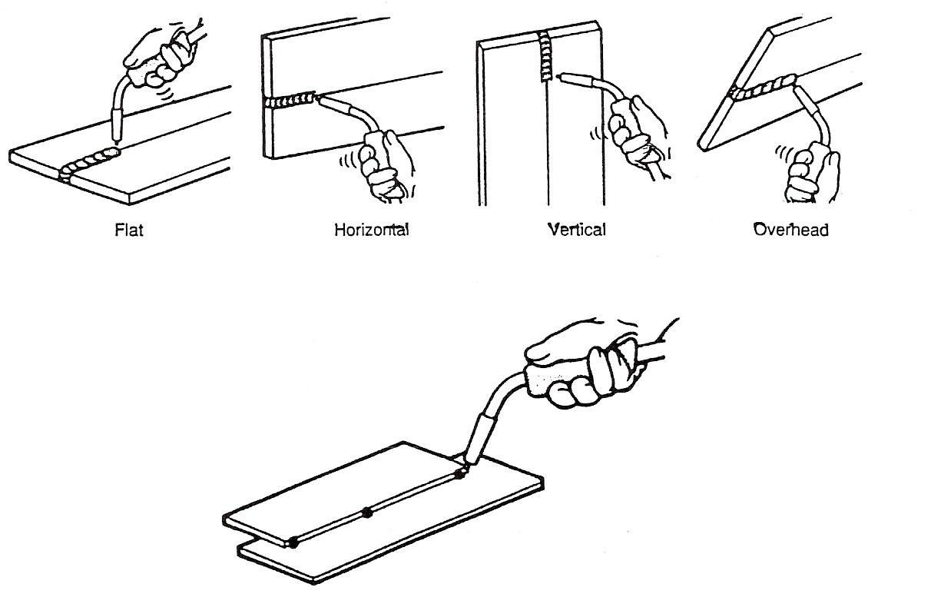
A tack is a relatively small temporary weld that is used instead of a clamp or a self-tapping screw, to tack and hold the panel in place while proceeding to make a permanent weld (Error: Reference source not found). Like the clamp or self-tapping screw, the tack weld is always and only a temporary device. The length of the tack weld is determined by the thickness of the metal panel to be welded and is approximately a length of 15 to 30 times the thickness of the metal panel. Tack welds must be done accurately, as they are very important in maintaining proper alignment and sometimes become part of the permanent weld.
Tack Weld

4.4 Welding Positions
There are 4 main welding positions for the deposition of material as shown in the illustration below. Spray transfer, pulsed transfer and dip transfer methods can be used for welds in the flat position, however for horizontal, vertical up or down and overhead welds only pulsed transfer or dip transfer methods are suitable.
Typical Welding Positions

4.5 MAGS Welding in the Flat Position
Closed Square Butt Joint – Spray Transfer in The Flat Position
- Establish the arc on the tack weld at the right-hand end of the joint.
- When fusion has been obtained to the full depth of the plate commence the leftwards progression.
- The electrode should be pointed at an angle of 75°-85° without weaving.
- Adjust the rate of travel so that the deposited metal is built up just proud of the plate surface and burn-through is avoided.
Visual Examination
The weld face should be of even width, free from undercut at the toes. The profile should be slightly convex.
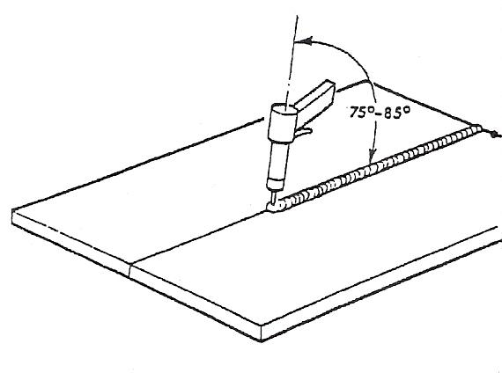
There should be full penetration with a slight penetration bead showing on the reverse side of the joint.
Material | 3/16" (5.0 mm) aluminium alloy, 2 off, min. 4" (10.0 cm) x 6" (15.0 cm)
Preparation | square edge
Assembly | Tack weld with three tacks, no gap. The use of a stainless steel grooved backing bar is recommended.
Electrode | 1/16˝ (1.6 mm)
Feed Rate | 240-290 in./min.
Argon | 35-45 ft.³/hr.
Current | 200-235 amperes
Arc Voltage | 25-26 volts

4.6 MAGS Welding in the Horizontal and Vertical Position
Open Square Butt Joint – Dip Transfer in the Horizontal Position
- Establish the arc at the right-hand end of the joint.
- Hold the torch so that the electrode wire is at right angles to the sheets.
- Adjust rate of travel to secure fusion without over-penetration.
Visual Examination
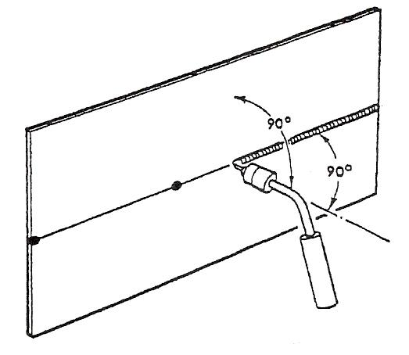
A neat weld profile with a uniform (but not excessive) penetration bead should be achieved.
Material | 3 mm MS plate
Preparation | square edge.
Electrode | 0.8 mm
Feed Rate | 130-140 in./min.
Carbon Dioxide | 25-30 ft.³/hr.
Current | 90-100 amperes
O.C. Voltage | 19-20 volts
Arc Voltage | 17-18 volts

Open Square Butt Joint – Dip Transfer in the Vertical Position
- Establish the arc at the top end of the joint.
- The electrode wire should be pointed upwards at an angle of 65°-75°.
- Direct the electrode wire at the gap between the sheets and adjust the rate of downwards travel to ensure even deposition and control of penetration.
Visual Examination
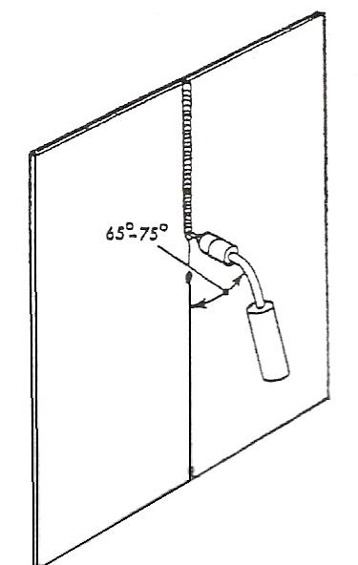
A neat weld profile with a uniform (but not excessive) penetration bead should be achieved.

Material | 5 mm or 6mm mild steel.
Preparation | - square edge.  - bevel to 30° on each plate. No root face.
Electrode | - 0.8 mm  - 1.2 mm
Feed Rate | - 100-110 in./min.  - 120-130 in./min.
Current | - 90-100 amperes  - 120-140 amperes
O.C. Voltage | - 19-20 volts  - 22-24 volts
Arc Voltage | - 17-18 volts  - 19-21 volts

4.7 Pipe and Tube Welds
There are three main types of welded joint used in pipework.
- butt
- branch
- flange
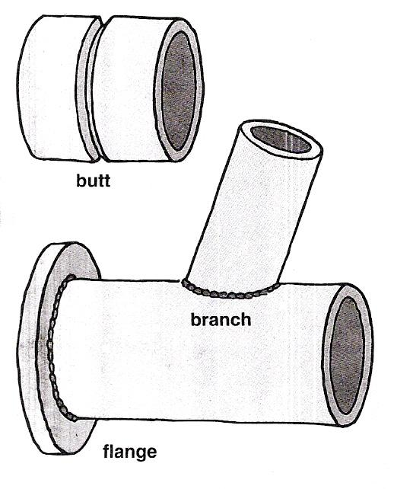
Pipe and Tube Joints
If possible, during welding the pipe should be rotated so that the weld is made in the horizontal position - use spray, dip or pulse transfer for MAGS welding. If the weld must be made in a fixed position and changes from flat to vertical to overhead as the weld progresses round the joint - use dip or pulse transfer for MAGS welding.
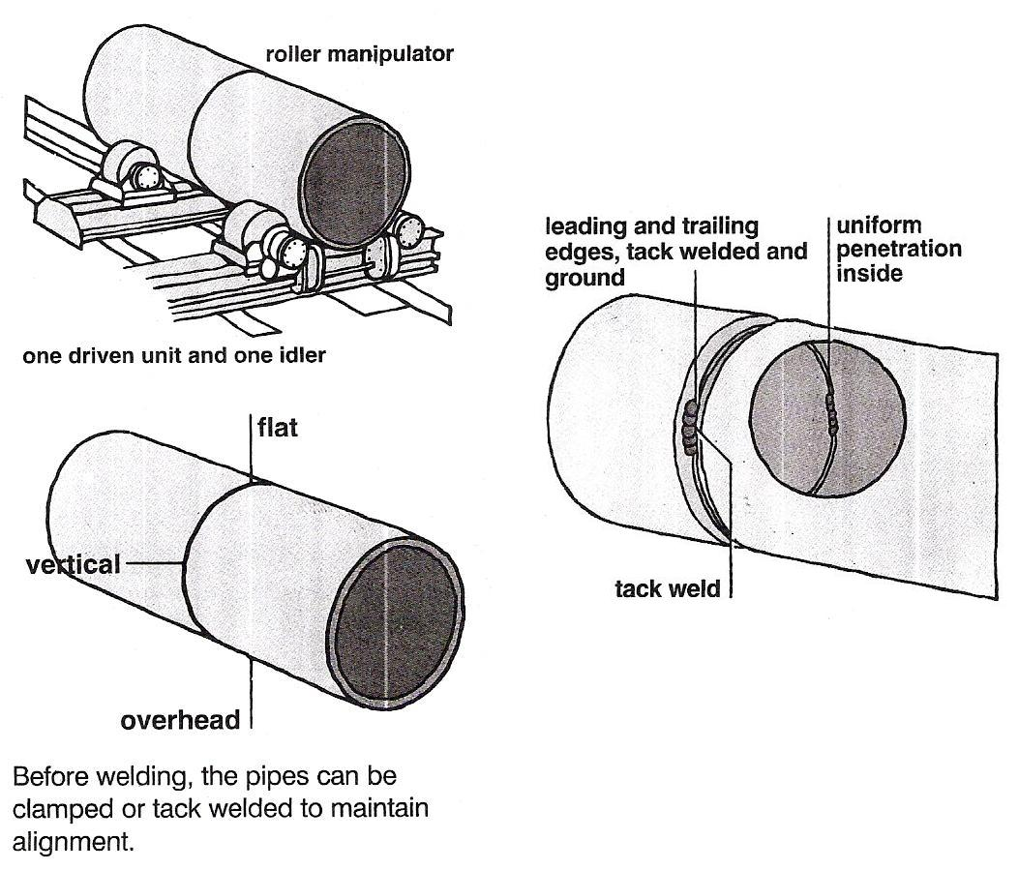
Welding positions when welding pipe

4.8 MIG Welding of Aluminium
While most welding equipment is supplied primarily for the welding of ferrous metals, some can also be used for the welding of aluminium. Equipment with low amperages is really not suitable, although it can be used for short periods of welding. The larger-amperage machines (180 A and over) are better equipped to handle aluminium. The wire sizes used are 1.0 mm and 1.2 mm for the larger machines for welding thicker aluminium. The torch contact tip must be of the correct size for the wire to be used. When welding with aluminium wire a Teflon liner must be used in order to prevent the aluminium from sticking and damage occurring to the wire itself. Also, pure argon must be used as the shielding gas owing to its total inert characteristics, and not argon mixes or carbon dioxide.

5.0 Identify Weld Defects and Their Causes

Key Learning Points
- Identification of weld defects
- Identify what causes weld defects
- Identify how weld defects can be avoided

5.1 Weld Quality
Most often, the major metric used for judging the quality of a weld is its strength and the strength of the material around it. Many distinct factors influence this, including the welding method, the amount and concentration of heat input, the base material, the filler material, the flux material, the design of the joint and the interactions between all these factors. To test the quality of a weld, either destructive or non-destructive testing methods are commonly used to verify that welds are defect-free, have acceptable levels of residual stresses and distortion and have acceptable heat-affected zone (HAZ) properties. Welding codes and specifications exist to guide welders in proper welding technique and in how to judge the quality of welds.

5.2 MAGS Weld Defects and Their Causes
Fault |  | Cause
Porosity | 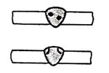 | - Insufficient CO2 shielding because of flow rate, frozen value, clogged nozzle, draughts.  - Torch angle too low.
Cracking | 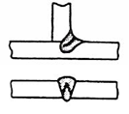 | - Dirty work – grease, paint, scale, rust  - Weld bead too small
Undercutting | 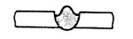 | - Travel speed too high  - Backing bar groove too deep  - Current too low for speed
Lack of penetration | 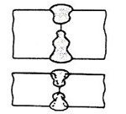 | - Current too low – setting wrong  - Wire feed fluctuating  - Joint preparation too narrow  - Angle too small, Gap too small  - Torch angle too low
Lack of fusion | 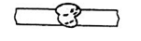 | - Uneven torch manipulation  - Insufficient indulgence (short circuiting arc)  - Voltage too low
Slag inclusions | 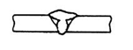 | - Incorrect technique  - Current too low  - Irregular weld shape
Spatter –  - on work  - on nozzle  - in weld | 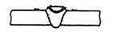 | - Voltage too high  - Insufficient inductance

Suggested Exercises
- Read and interpret drawing related to welding exercises
- Assemble, adjust and operate a MAGS welding plant to complete exercises listed below.
- Complete welding exercises No. 2.2.4a
- Complete welding exercises No. 2.2.4b
- Complete welding exercises No. 2.2.4c
- Complete welding exercises No. 2.2.4d
- List the dangers/hazards and recommended safety precautions pertaining to electric arc (MIG) welding

Additional Resources
Title | Author | Ref. Code
The Induction Book, “Code of Behaviour & Health & Safety Guidelines” | SOLAS
Basic Welding and Fabrication | W Kenyon | ISBN 0-582-00536-L
Fundamentals of Fabrication and Welding Engineering | FJM Smith | ISBN 0-582-09799-1
Workshop processes, practices and materials, 3rd edition, Elsevier Science & Technology | Black, Bruce J 2004 | ISBN-13: 9780750660730
New Engineering Technology | Lawrence Smyth & Liam Hennessy | ISBN 086 1674480

Videos
- Understanding welding fumes
- Welder on Site…Be Aware (Vocam)
- Powered hand tool safety (Vocam)
- Industrial Ergonomics (Vocam)
Available from:
Vocam Ireland
Circle Organisation Ltd
Friar Street, Thurles, Co Tipperary, Ireland
Tel: +353 504 24666

Castleforbes House
Castleforbes Road
Dublin 1

